

|  |
| --- |
| Review Real Estate |
|  |
| **26 septemper**  Across Border  CE130377 Nguyen Thanh Nhan  CE130252 Nguyen Chi Linh  CE130242 Mac Truong Hai  CE130431 Ma Anh Hoang |
| Approve by Vo Hong Khanh |

Table of Contents

I. Problem definition 3

II. User requirement 4

a. Functions 4

i. For employee by role 4

ii. For client 4

b. Hardware and software 4

III. Schedule and role 5

a. Project plan and role 5

b. Role 5

c. Schedule 6

IV. Design pattern 8

a. System Organization 8

i. Use-case diagram 8

ii. Class diagram 10

iii. Sequence diagram 12

b. Database 12

i. DB Diagram 12

ii. Table structure 13

c. Interface 16

i. For Admin 16

ii. For Client 16

V. Execution flow 17

a. Algorithm diagram 17

VI. Maintenance 18

VII. Checklist 19

# Problem definition

Today, when society is development technology 4.0 is applied a lot in many fields such as business, medicine, study, and sales... Today we will apply technology to the real estate. We will design a website to help buyers and sellers have more advantages in real estate trading. First, the benefit of the buyer, they can access website, then register a personal account, which allows users to view real estate details such as price, area, address... they can contact the landlord directly by phone number or some other means, depending on the seller. Help buyers can refer to many real estates without having to go to each place and can choose many real estate suitable for you such as price, area, address... In terms of the interests of the seller, the seller does not need to spend much time to advertise real estate in many places, does not spend much money to hire intermediaries to sell real estate. The seller only needs to provide the correct information to the admin side of website, then the admin will post the details of the real estate to the buyer. The buyer will then contact the seller directly via phone number or some other form. Those are the benefits of real estate website when writing down if users require more, we will develop more functions to meet the needs of the most effective use.



# User requirement

## Functions

### For employee by role

Employee account: when employee logged into to post their product. The post-posting function will have:

* + Login: change password, change information, logout, change password
  + Post-posting
  + Manage a post:
    - * Edit post
      * Delete post
      * Search post
      * Sorting post
      * Panging and list
      * View information of post
  + Keep a diary of meetings

Admin account: manage websites and database, creates account, manage role of all account. The admin function will have:

* + Login: change password, change information, logout, change password
  + Post-posting
  + Manage a post
    - * Edit post
      * Delete post
      * Search post
      * Sorting post
      * Panging and list
      * View information of post
* Manage employee
  + - * Delete employee
      * Search employee
      * Sorting employee
      * Panging and list
      * View information of employee
      * Reset password
* Manage customer
  + - * Delete customer
      * Search customer
      * Sorting customer
      * Panging and list
      * View information of customer
      * Reset password

### For client

Client function will has:

* + Register
  + Login: change information, change password, logout
  + View information of product for detail
  + Contact with employee

## Hardware and software

|  |  |  |
| --- | --- | --- |
|  | Client device | Server computer |
| Hard requirement | - CPU: Pentium IV 2.0 GHz or higher, smartphone, tablet  - RAM: 1GB or higher.  - HDD: 1GB or higher. | CPU: AMD Opteron 6272 2.1Ghz or higher  - RAM: 8GB or higher.  - HDD: 500MB or higher  - Network Interface Controller |
| Software requirement | - Operating System: mac OS 10.12+, Windows 8.1+, Android and iOS.  - Chrome/Firefox/Opera. | - MySQL Server  - Operating System: Windows Sever 2016 or higher  - JRE  - Glassfish Server |

# 

# Schedule and role

## Project plan and role

* + 1. Project plan
       - Date of project plan:

+ Start: September 26th, 2019

+ End:

* + 1. Project Vision/Objective:
       - The goal of project to review real estate around the Can Tho city.
       - The client can see a lot of house, land in our websites.

## Role

|  |  |  |  |
| --- | --- | --- | --- |
| No. | Member | Role | Responsibilities |
| 1 | Nguyen Thanh Nhan | Project Manager | Tester, Plan Builder, Coder, Code Interface |
| 2 | Nguyen Chi Linh | Developer | Coder, Manage Project, Code Interface |
| 3 | Mac Truong Hai | Developer | Coder, Designer, Tester |
| 4 | Ma Anh Hoang | Developer | Coder, Tester |

## Schedule

|  |  |  |  |  |  |
| --- | --- | --- | --- | --- | --- |
| No. | Member | Task | Details | Work start time | Time estimates |
| 1 | Nhan, Linh, Hai | Synthetic documents | Searching document for project | 09/27/2019 | 6h |
| 2 | Hai, Hoang | Design interface | Design file pts interface (admin, product page) | 09/30/2019 | 3h |
| 3 | Nhan, Linh | Design interface | Design file pts interface (home, introduce page) | 09/30/2019 | 3h |
| 4 | Nhan, Linh | Coding | Convert file pts to html(home, introduce page) | 10/05/2019 | 12h |
| 5 | Hai, Hoang | Coding | Convert file pts to html(home, introduce page) | 10/05/2019 | 12h |
| 6 | All | Design database | Analysis database | 10/08/2019 | 14h |
| 7 | All | Estimates function | Analysis function | 10/09/2019 | 10h |
| 8 | All | Coding | All of object class and model class | 10/09/2019 | 2h |
| 9 | Nhan, Linh | Sequence diagram | Draw sequence diagram(Add employee) | 10/15/2019 | 3h |
| 10 | Hai, Hoang | Sequence diagram | Draw sequence diagram(Add product) | 10/15/2019 | 3h |
| 11 | All | Coding | Back and coding, connect to the DB in local | 10/20/2019 | 48h |
| 12 | Linh | PowerPoint | Design PowerPoint | 11/06/2019 | 2h |
| 13 | All | Test and complete | Test project by all of member and complete | 11/11/2019 | 4h |

# Design pattern

## System Organization

### Use-case diagram

1. Customer

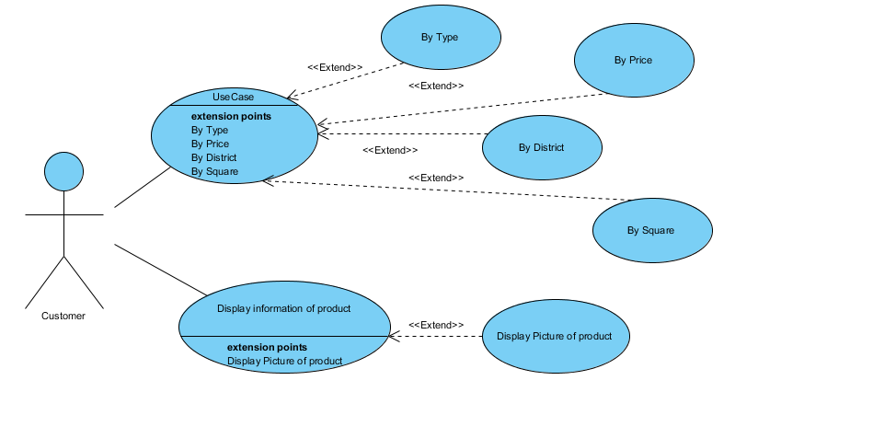

1. Employee

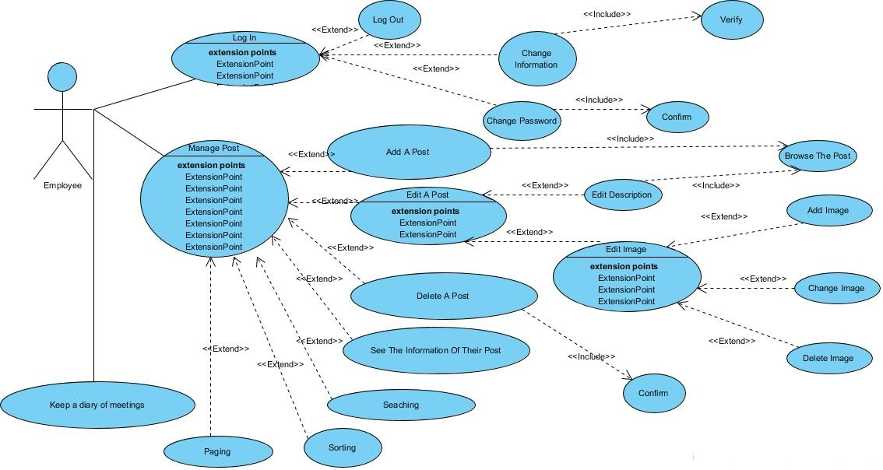

1. Admin

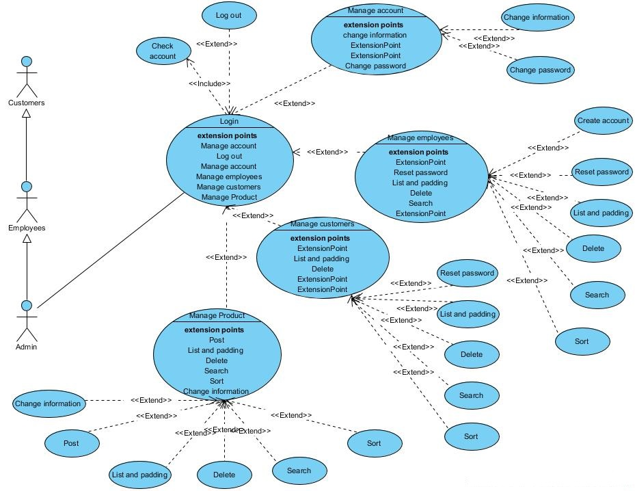

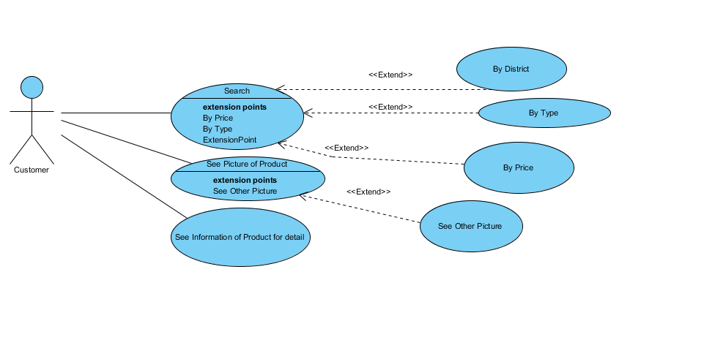

### Class diagram

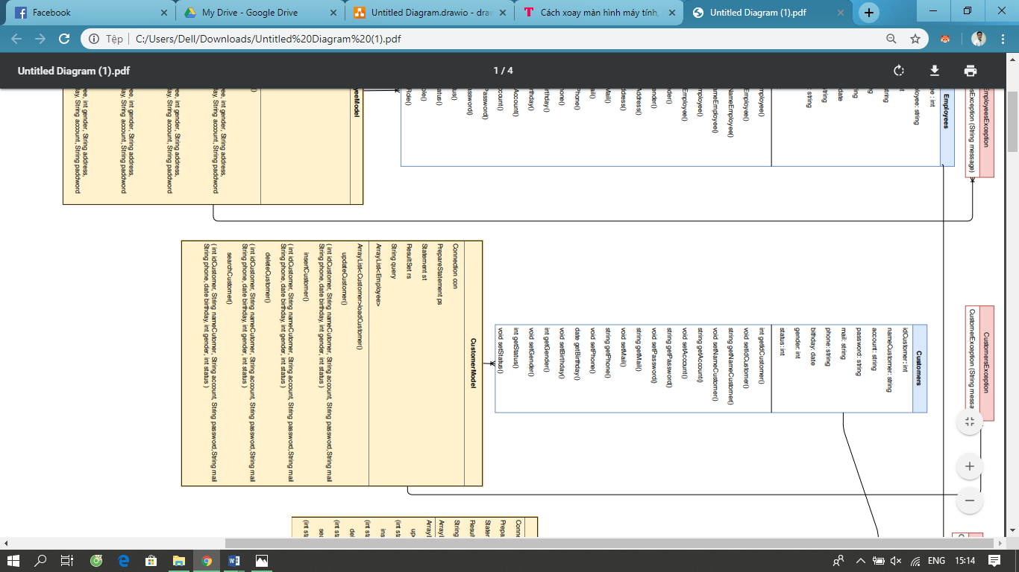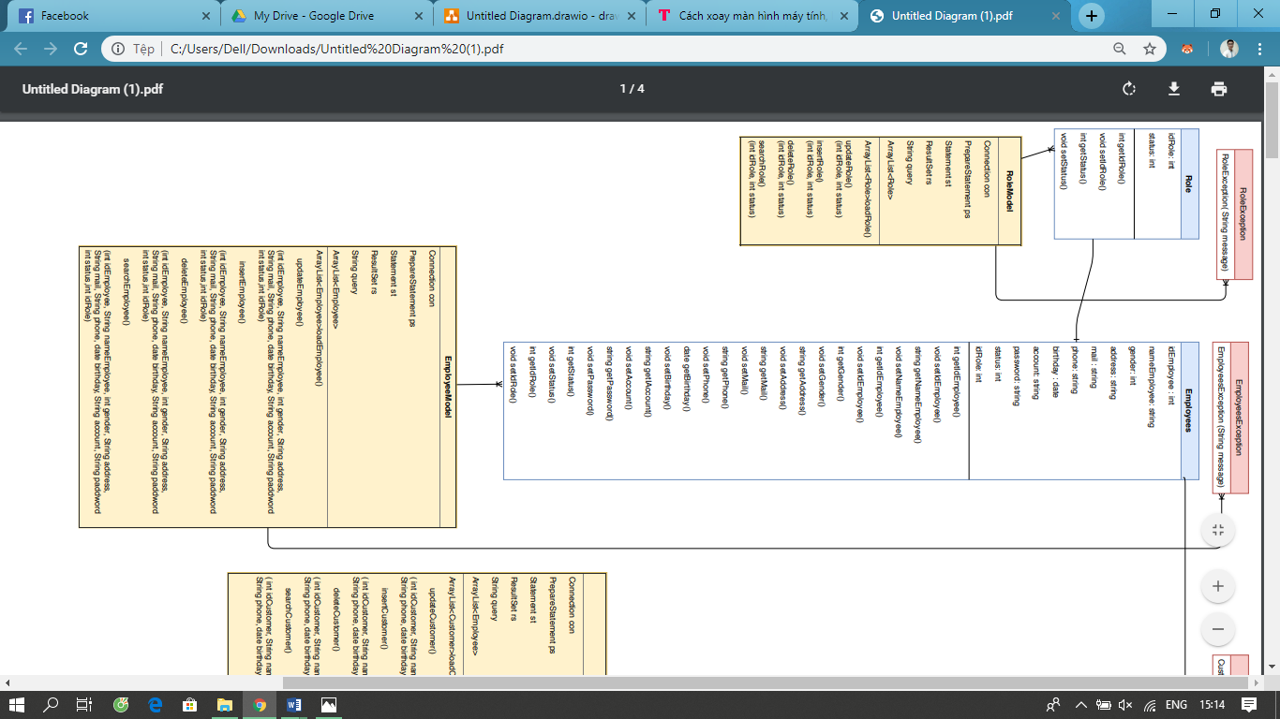

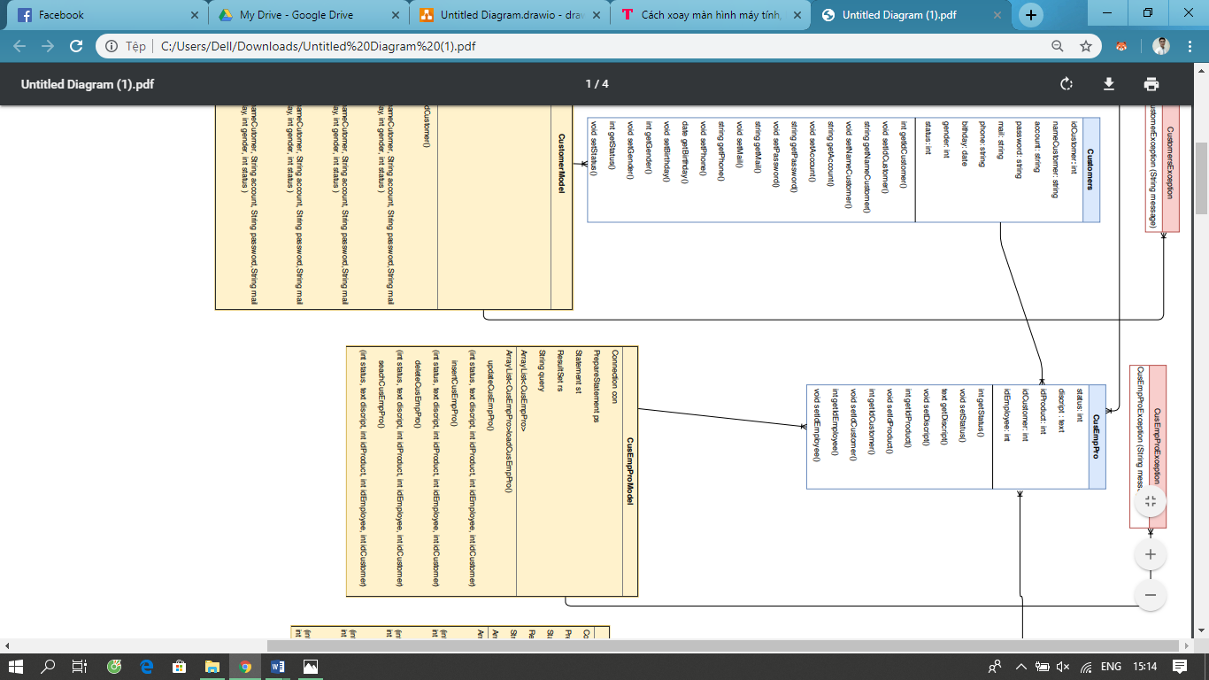

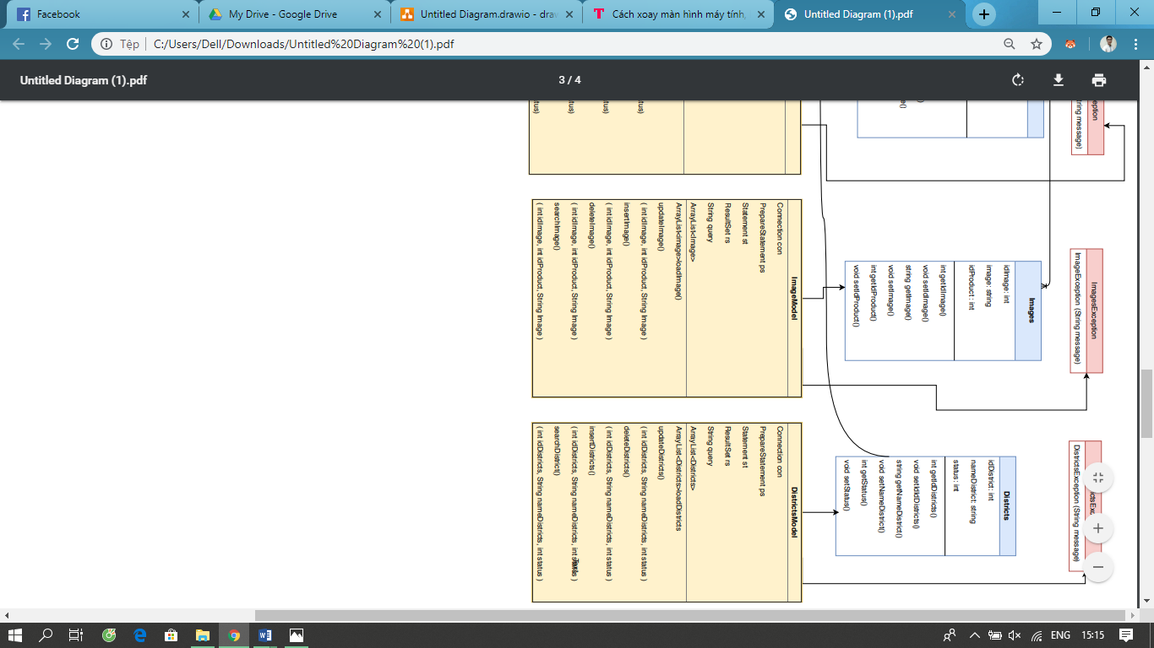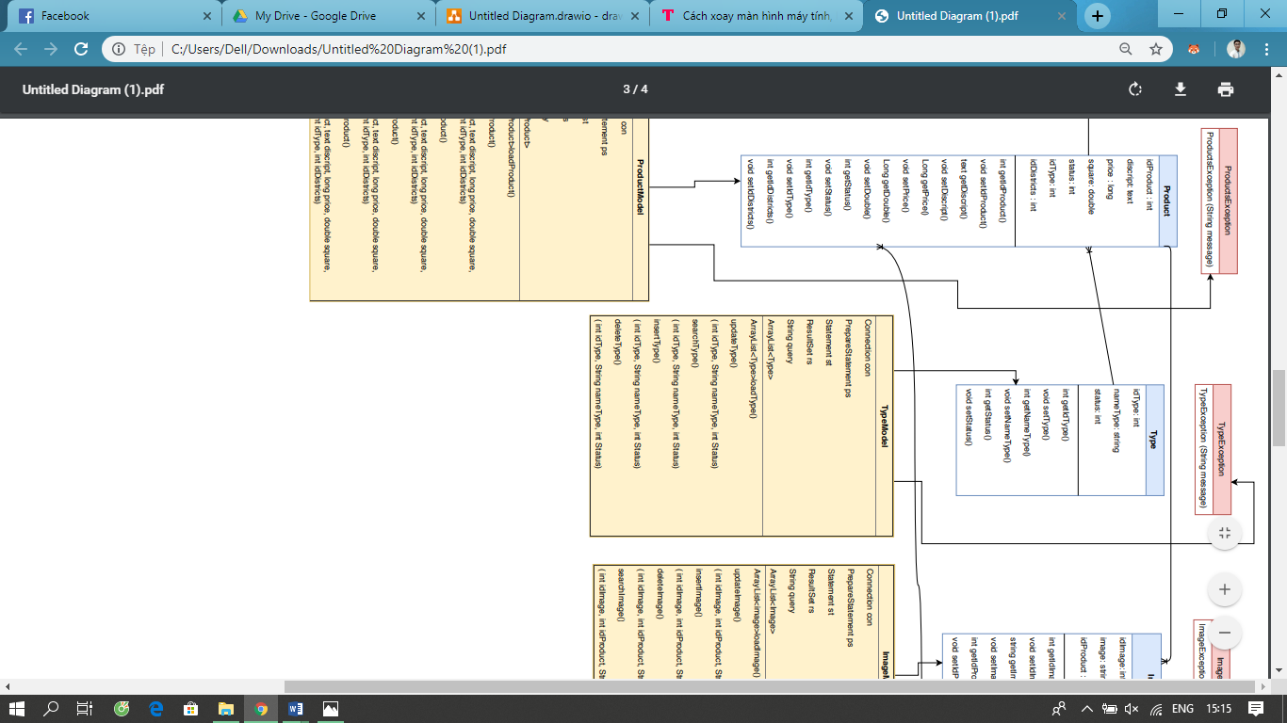

### Sequence diagram

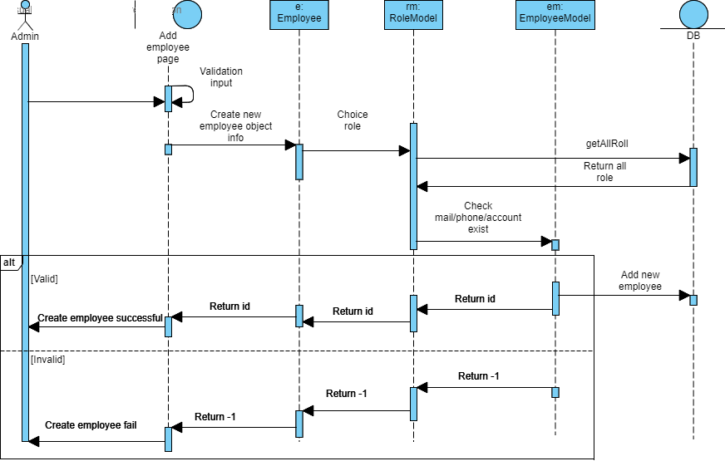

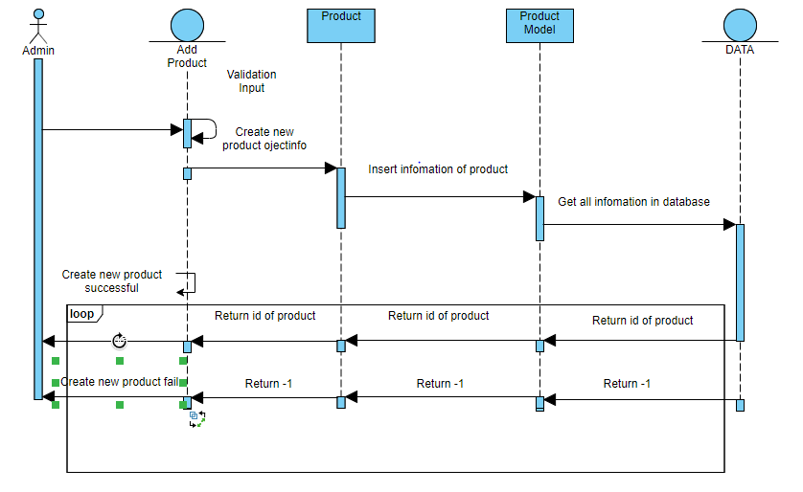

## Database

### DB Diagram

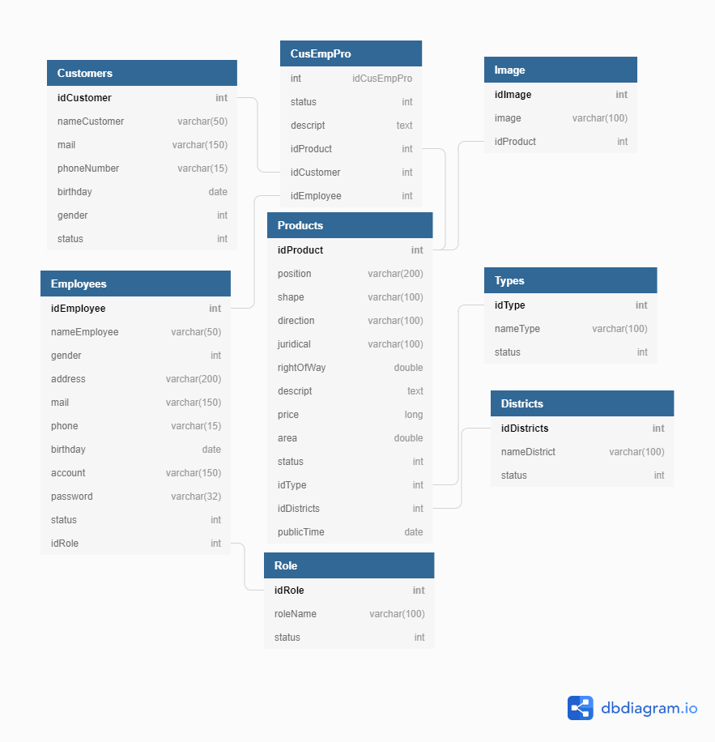

### Table structure

TABLE 1. CUSTOMERS

|  |  |  |  |
| --- | --- | --- | --- |
| Field Name | Data Type | Constraint | Description |
| idCustomer | Int | PRIMARY KEY, NOT NULL | Id of customer |
| nameCustomer | Varchar(50) | NOT NULL | Name of customer |
| mail | Varchar(150) | NOT NULL | Mail of customer |
| phoneNumber | Varchar(15) | NOT NULL | Phone of customer |
| birthday | Date | NOT NULL | Birthday of customer |
| gender | Int | NOT NULL | Gender of customer |
| status | Int | NOT NULL | Status of customer |

TABLE 2. EMPLOYEES

|  |  |  |  |
| --- | --- | --- | --- |
| Field Name | Data Type | Constraint | Description |
| idEmployee | Int | PRIMARY KEY, NOT NULL | Id of employees |
| nameEmployee | Varchar(50) | NOT NULL | Name of employees |
| gender | Int | NOT NULL | Gender of employees |
| address | Varchar(200) | NOT NULL | Address of employees |
| mail | Varchar(150) | NOT NULL | Mail of employees |
| phone | Varchar(15) | NOT NULL | Phone of employees |
| birthday | Date | NOT NULL | Birthday of employees |
| account | Varchar(150) | NOT NULL | Account of employees |
| password | Varchar(32) | NOT NULL | Password of employees |
| status | Int | NOT NULL | Account’s status |
| idRole | Int | NOT NULL | Position of employees |

TABLE 3. ROLE

|  |  |  |  |
| --- | --- | --- | --- |
| Field Name | Data Type | Constraint | Description |
| idRole | Int | PRIMARY KEY, NOT NULL | Id of role |
| roleName | Varchar(100) | NOT NULL | Role name |
| status | Int | NOT NULL | Status of role |

TABLE 4. CUS-EMP-PRO

|  |  |  |  |
| --- | --- | --- | --- |
| Field Name | Data Type | Constraint | Description |
| status | Int | NOT NULL | Status |
| descript | Text | NOT NULL | Descript |
| idProduct | Int | FOREIGN KEY, NOT NULL | Id product |
| idCustomer | Int | FOREIGN KEY, NOT NULL | Id customer |
| idEmployee | Int | FOREIGN KEY, NOT NULL | Id employee |

TABLE 5. PRODUCT

|  |  |  |  |
| --- | --- | --- | --- |
| Field Name | Data Type | Constraint | Description |
| idProduct | Int | PRIMARY KEY, NOT NULL | Id of product |
| position | Varchar(200) | NOT NULL | Position of product |
| shape | Varchar(100) | NOT NULL | Shape of product |
| direction | Varchar(100) | NOT NULL | Direction of product |
| juridical | Varchar(100) | NOT NULL | Juridical of product |
| rightOfWays | Double | NOT NULL | Right of ways of product |
| descript | Text | NOT NULL | Descript of product |
| price | Long | NOT NULL | Price of product |
| square | Double | NOT NULL | Square of product |
| status | Int | NOT NULL | Status of product |
| idType | Int | FOREIGN KEY, NOT NULL | Id type of product |
| idDistrict | Int | FOREIGN KEY, NOT NULL | Id district of product |

TABLE 6. TYPE

|  |  |  |  |
| --- | --- | --- | --- |
| Field Name | Data Type | Constraint | Description |
| idType | Int | PRIMARY KEY, NOT NULL | Id type |
| nameType | Varchar(100) | NOT NULL | Name of type |
| status | Int | NOT NULL | Status of type |

TABLE 7. IMAGE

|  |  |  |  |
| --- | --- | --- | --- |
| Field Name | Data Type | Constraint | Description |
| idImage | Int | PRIMARY KEY, NOT NULL | Id image |
| Image | Varchar(100) | NOT NULL | Path image |
| idProduct | Int | FOREIGN KEY, NOT NULL | Id of product |

TABLE 8. DISTRICTS

|  |  |  |  |
| --- | --- | --- | --- |
| Field Name | Data Type | Constraint | Description |
| idDescription | Int | PRIMARY KEY, NOT NULL | Id of description |
| nameType | Varchar(100) | NOT NULL | Name of type |
| status | Int | NOT NULL | Status of type |

## Interface

### For Admin

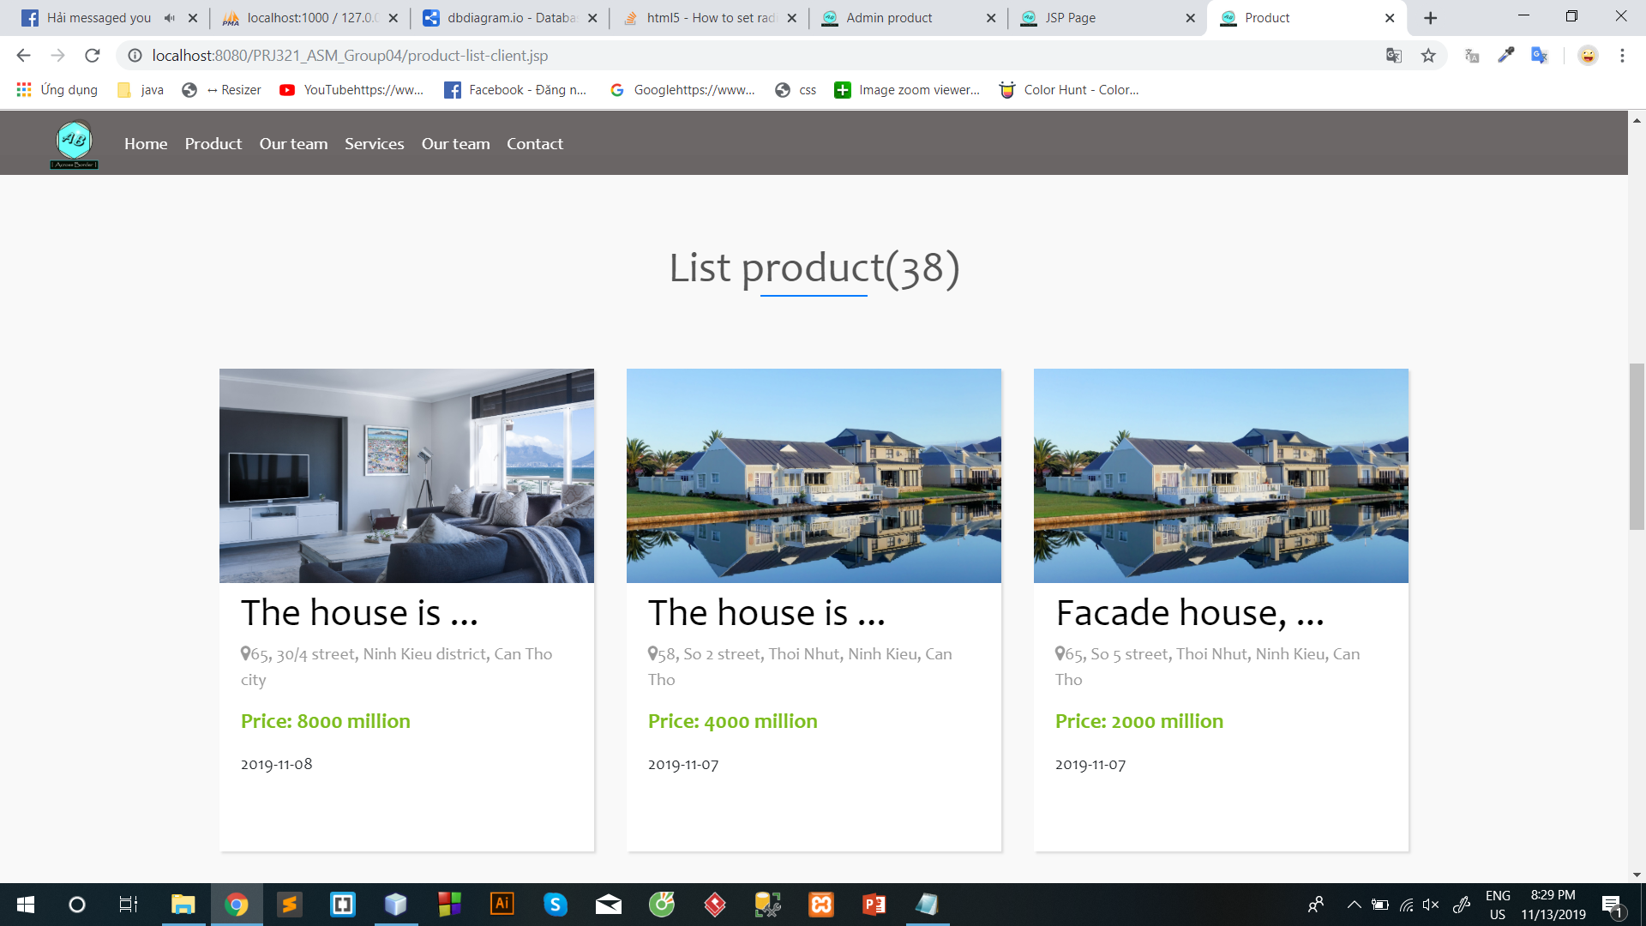

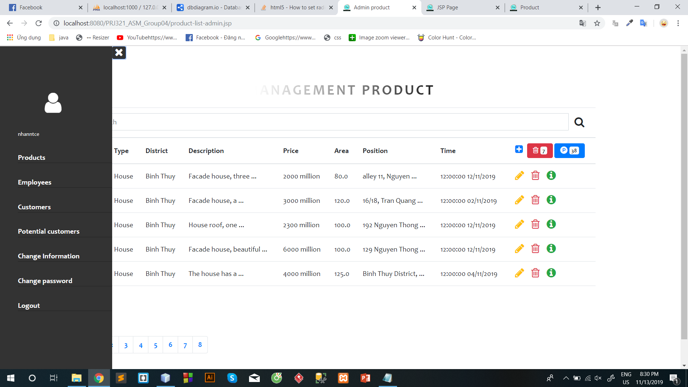

### For Client

### 

### 

### 

### 

### 

# Maintenance

The system is constantly updated as new products become available

The system is maintained once a month by the our information technology center.

# Checklist

|  |  |  |  |  |  |  |  |
| --- | --- | --- | --- | --- | --- | --- | --- |
| No. | Document Name | Date | Estimated number of hours completed | Complete  time | Real  time | Member names | Note |
| 1 | Problem definition | 26/09/2019 | 2 | 14:00  26/09/2019 | 2 | Nhan, Hai | Complete |
| 2 | User requirement | 26/09/2019 | 4 | 14:00  26/09/2019 | 3 | Nhan, Hai | Complete |
| 3 | Analysis | 30/09/2019 | 12 | 12:00  30/09/2019 | 11 | All | Complete |
| 4 | Making document | 10/10/2019 | 6 | 20:00  10/10/2019 | 5 | All | Complete |
| 5 | Design database diagram | 05/10/2019 | 15 | 23:00  05/10/2019 | 16 | All | Complete |
| 6 | Use case diagram | 03/10/2019 | 2 | 14:00  03/10/2019 | 1.5 | All | Complete |
| 7 | Sequence Diagram | 06/10/2019 | 2 | 14:00  06/10/2019 | 2 | All | Complete |
| 8 | Coding | 07/10/2019 -10/11/2019 | 136 | 22:00  11/11/2019 | 138 | All | Complete |
| 9 | Testing | 12/11/2019 | 1 | 15:00  12/11/2019 | 1 | All | Complete |
| 10 | Complete PP and Document | 13/11/2019 | 2 | 20:00  13/11/2019 | 2 | Hai, Linh | Complete |